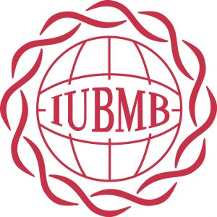
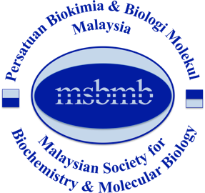
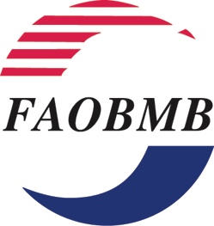

APPLICATION FORM

Young Scientist Program for 27th FAOBMB-44th MSBMB Conference
Kuala Lumpur, Malaysia, 15-18 August, 2019

PART 1:

Name of Applicant: Mr / Mrs/ Ms / Dr ……………………………………

Gender:

Position:

Address of Applicant:
(Normally this will be your institutional or office address)

Email address:

Membership of FAOBMB Constituent Society:
Indicate the Constituent Society of FAOBMB in your country/region of residence which you are a member. Please refer to the PART 7 below.

Provide membership Number (if available) ………………………
You must provide, as an attachment, a statement of certification of your valid membership confirmed by the Secretary or other responsible officer of the Constituent Society

APPLICANT’S DECLARATION

I hereby declare that all the information given above and any other supplementary information attached in connection to my application, whether on this document or not, are accurate and to the best of my knowledge true and correct. I understand that any misrepresentation, falsification, or omission of information would result in the disqualification of my application for Young Scientist Award, 27th FAOBMB-44th MSBMB Conference

Signature of Applicant | Endorsement by supervisor/HOD (to sign)
Date | Name:  Position:  Date:
Attachments required:

PART 2: Latest Curriculum Vitae

- Including education, career experience and awards received

PART 3: Publications

- List of Publications in International Journals *

- Full list of publications
- Highlighted list of top five publications

Please provide extra information on your top five publications, in a separate list.
In this list, for each of the five publications, you should list the impact factor (IF) of the journal, the significance of the outcomes of this work to the field, and your role and contribution to the work described.

PART 4: Statement of Purpose for participation in the YSP 2019

- Brief Synopsis of Your Research Interests and Career Goals: (no more than one page)

PART 5: Abstract

- The Abstract that you have submitted or plan to submit for presentation at the Conference.
PART 6: Two (2) Letters of Recommendation

PART 7: Certification of the applicant’s current membership an IUBMB / FAOBMB-related National Society of Biochemistry and Molecular Biology, provided by the Secretary or other responsible officer of that Society.

(NOTE: If you do not have a valid IUBMB membership, please contact the corresponding organization in your country of origin). A list of Constituent Member societies of FAOBMB is provided on the FAOBMB webpage at: http://faobmb.com/about-faobmb/constituent-members/. A list of Adhering Bodies and Associate Adhering Bodies of IUBMB is provided on the webpage at: https://iubmb.org/adhering-bodies-and-associate-adhering-bodies/.

All of the above documents should be merged into a single PDF file.
The filename should be saved as follows:
  - Application for YSP2019_Lastname_Firstname.PDF

Submission: The assembled PDF file must be sent by email to IUBMB-YSP 2019 Secretariat, Dr Yap Wei Hsum at iubmb2019.ysp@gmail.com by 28 February 2019.

- The application deadlines are based on Malaysian Standard Time. (GMT+8)

